**LAB 5 TASKS:**

**PRACTICE TASK 1:**

**CODE:**

#include<iostream>

using namespace std;

class passport

{

private:

string full_name;

int passport_num;

string nationality;

string gender;

string citizenship_num;

public:

passport()

{

cout << " Enter citizenship number in the given format : " << endl;

cout << " *****-*******-* " << endl;

cin >> citizenship_num;

}

passport(string f_n, string l_n)

{

full_name = f_n + l_n;

cout << " full name : " << full_name << endl;

}

passport(string Gender, string Nationality, int Passport_n)

{

gender = Gender;

nationality = Nationality;

passport_num = Passport_n;

cout << " gender : " << gender << endl;

cout << " nationality : " << nationality << endl;

cout << " passport number : " << passport_num << endl;

}

void display()

{

cout << " citizenship number : " << citizenship_num << endl;

}

};

void main()

{

passport obj;

passport obj2("NOOR", "-UL-AIN");

passport obj3("female", "pakistan", 123456789);

obj.display();

}

**OUTPUT:**

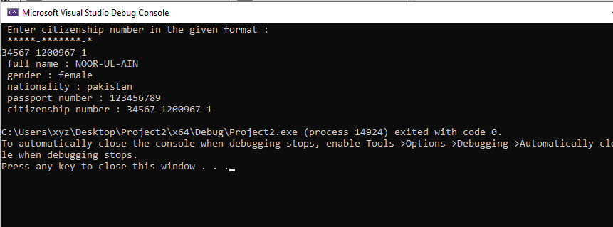

**PRACTICE TASK 2:**

**CODE:**

#include<iostream>

using namespace std;

class passport

{

private:

string full_name;

int passport_num;

string nationality;

string gender;

string citizenship_num;

public:

passport()

{

cout << " Enter citizenship number in the given format : " << endl;

cout << " *****-*******-* " << endl;

cin >> citizenship_num;

}

passport(string f_n, string l_n)

{

full_name = f_n + l_n;

cout << " full name : " << full_name << endl;

}

passport(string Gender, string Nationality, int Passport_n)

{

gender = Gender;

nationality = Nationality;

passport_num = Passport_n;

cout << " gender : " << gender << endl;

cout << " nationality : " << nationality << endl;

cout << " passport number : " << passport_num << endl;

}

void display()

{

cout << " citizenship number : " << citizenship_num << endl;

cout << " citizenship number printing by using copy constructor : " << citizenship_num << endl;

}

};

void main()

{

passport obj;

passport obj2("NOOR", "-UL-AIN");

passport obj3("female", "pakistan", 123456789);

passport obj4(obj);

obj4.display();

}

**OUTPUT:**

